|  |
| --- |
| **UNIVERSITY OF CENTRAL PUNJAB**  **FACULTY OF INFORMATION TECHNOLOGY**  **ITC**  **MID TERM EXAM**  **Fall 2021** |

**Instructions:**

* **There are two questions.**
* **There are four pages.**
* **Examples are given as a sample, but your program should work on different inputs as well.**
* **Total exam time is 1 Hour 30 min.**
* **Submit one ZIP folder on portal containing .cpp files only.**
* **Plagiarism will not be tolerated.**

Task 1 (15 Marks)

A farmer is asking you to count total legs of all his animals. The farmer breeds three species.

|  |  |
| --- | --- |
| Animal breeds | Number of legs |
| Chicken | 2 |
| Cow | 4 |
| Horse | 4 |

The farmer will give you the count of each animal breed **(take input from the user).** You have to write a C++ program that calculates the total number of legs of all animals.

**Note: Count of animals must be a positive integer.**

**Example 1: Example 2:**

**Figure 1: Sample 1**

**Figure 2: Sample 2**

Task 2 (15 Marks)

Amjad reached Emporium with his family. They are all excited since he successfully passed his test for BSCS admission and now, they are here to celebrate. All the family members are interested in watching the movie while having popcorn. You must ask Amjad the number of people with him. Emporium Cinema is offering different type of tickets for the film: [Student (S) 250, Normal (N) 400, and Executive (E) 750]. Any choice other than mentioned is considered as invalid input. Ask them what ticket choice will they prefer. Before the start of the film, all the family members decide to have popcorn also. Popcorn stall is offering three different flavors. [Simple (S) 100, Tacos (T) 150, and Caramel (C) 200]. Any choice other than mentioned is considered as invalid input. Ask them what popcorn choice will they prefer.

Calculate and print the amount used for the ***film***and ***popcorn*** ***separately*** and the ***total expense*** *at the* ***end***. Your solution should show proper menu-based system.

**Example 1:**

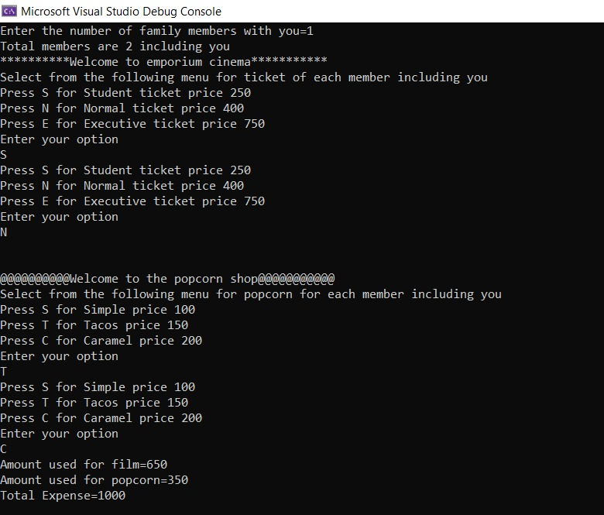

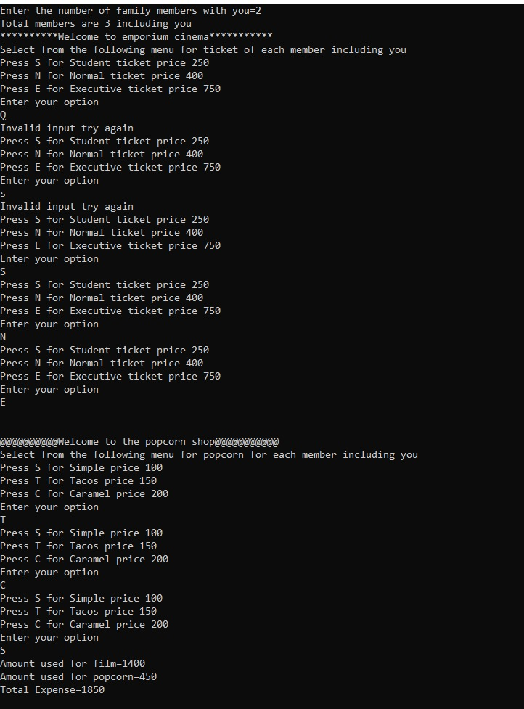**Example 2:**